ECA56 — CO3 AT2 Design Task
Question 9: Design a Cloud Radio Access Network (C-RAN) Model for Dense Urban Deployment

1. Objective
To design a Cloud Radio Access Network (C-RAN) for dense urban areas to provide high capacity, efficient resource allocation, low latency, and improved coverage.

2. Proposed C-RAN Architecture

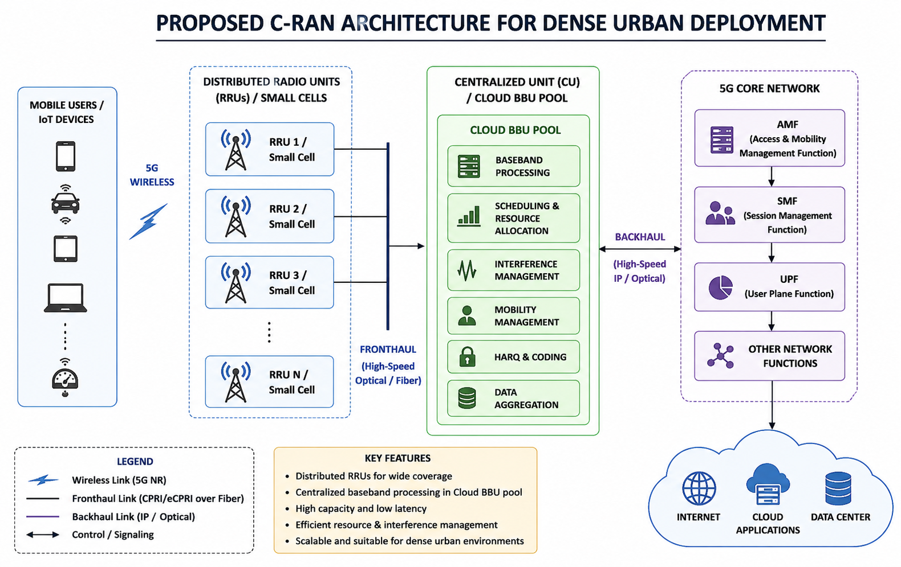

3. Main Components
Component | Function
Mobile users | Generate and receive wireless data
RRUs / small cells | Provide radio coverage across the dense urban grid
Fronthaul | Connects RRUs to the centralized BBU pool over fibre
Cloud BBU pool | Performs centralized, virtualized baseband processing
5G core | Handles session management and network connectivity
Internet / cloud | Provides external services and applications

4. Working Principle
- Mobile users connect to nearby RRUs using 5G wireless communication.
- RRUs collect and transmit the received signals.
- Signals are transferred to the centralized BBU pool through high-speed fronthaul.
- The BBU pool performs baseband processing and resource allocation.
- Interference and mobility are managed centrally across all RRUs.
- Processed data is forwarded through the 5G core network.
- Data finally reaches the Internet / cloud services.

5. Design Parameters
Parameter | Value
Network | 5G C-RAN
Deployment | Dense urban
Number of RRUs | 6
Number of users | 50
Area | 1000 x 1000 m
Carrier frequency | 3.5 GHz
Bandwidth | 100 MHz
RRU power | 30 dBm
Fronthaul | Optical / fibre (eCPRI)

6. MATLAB Simulation
% C-RAN Dense Urban Deployment
A = 1000; % Area (m)
R = 6; % Number of RRUs
U = 50; % Number of users
BW = 100e6; % Bandwidth
Pt = 30; % RRU power (dBm)
% RRU and user positions
r = A*rand(R,2);
u = A*rand(U,2);
% Distance and received power
for i = 1:U
for j = 1:R
d(i,j) = max(10,norm(u(i,:)-r(j,:)));
Pr(i,j) = Pt - (32.4 + 20*log10(3.5) ...
+ 30*log10(d(i,j)));
end
end
% User association and SINR
[Pmax,id] = max(Pr,[],2);
SINR = 10.^(Pmax/10);
for i = 1:U
I = sum(10.^(Pr(i,:)/10))-SINR(i);
SINR(i) = SINR(i)/(I+10^(-174/10));
end
% Throughput
T = (BW/U)*log2(1+SINR);
fprintf('Average SINR = %.2f dB\n', ...
mean(10*log10(SINR)));
fprintf('Average Throughput = %.2f Mbps\n', ...
mean(T)/1e6);
% Deployment plot
scatter(u(:,1),u(:,2),'b','filled');
hold on;
scatter(r(:,1),r(:,2),100,'r','filled','^');
grid on;
xlabel('X (m)');
ylabel('Y (m)');
title('Dense Urban C-RAN Deployment');
legend('Users','RRUs');

7. Simulation Output
The MATLAB program provides:
- Average SINR
- Average throughput
- User-RRU association
- Dense urban deployment plot
The plot shows the distribution of mobile users and RRUs / small cells across the 1000 x 1000 m urban area, with each user linked to its strongest-SINR RRU.

8. Advantages
- High network capacity
- Efficient spectrum utilization
- Centralized resource management
- Reduced interference through joint scheduling
- Low latency
- Easy network scaling
- Suitable for dense urban 5G deployment

9. Limitations
- Requires high-speed, low-latency fronthaul
- Centralized BBU pool requires high processing power
- Fronthaul deployment (fibre trenching) can be expensive in dense cities
- Failure of the central unit can affect multiple RRUs simultaneously

10. Improvements
AI-based traffic prediction can be added to dynamically allocate resources according to user demand. Edge computing (MEC) can also be integrated at the BBU pool to reduce latency for critical, real-time applications such as smart-city and public-safety services.

11. Conclusion
The proposed C-RAN model uses distributed RRUs connected to a centralized cloud BBU pool through high-speed fronthaul. Centralized processing enables efficient resource allocation, interference management, high capacity, scalability, and low latency, making the architecture suitable for dense urban 5G networks.

